Morgan & Mom Tips:
- Make learning meaningful.
- Include them. Let them help you.
- Your child is your best teacher. Follow their lead.
- Developmental delay is just that. Keep challenging. “Rinse and Repeat”
- Do-overs will be necessary. Forgive yourself.
- Maturity will come for both of you. Hang in there.
- Don’t compare. Look for a personal best.
- Celebrate.

Making a Shared Masterpiece:
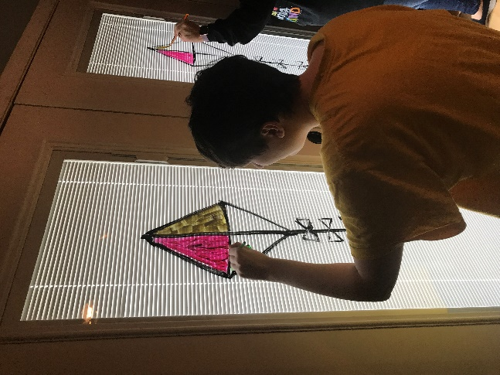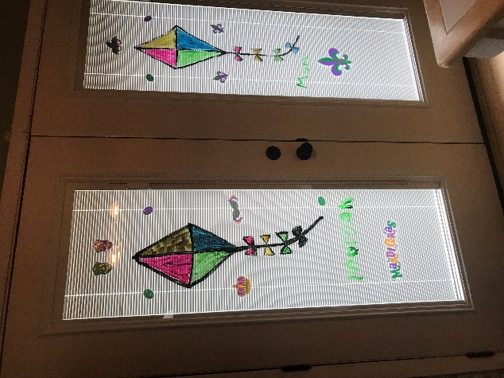
- Make sure you have time, all your materials, and a plan.
- Be ready to change the plan.
- Say it and Display it for the visual learner.
- Break it down into shapes.
- Take turns.
- Enjoy – It’s about the process.

Follow our family on Facebook and Wordpress
Tammy Vice - Know the Hope KnowtheHopeinc.com

